**M**erge sort

On a "traditional" merge sort, each pass through the data doubles the size of the sorted subsections. After the first pass, the file will be sorted into sections of length two. After the second pass, length four. Then eight, sixteen, etc. up to the size of the file. V

**O (n log n)**

**M**erge sort is based on the **divide-and-conquer** paradigm. It is a non-tail recursion algorithm.

To sort A[p .. r]:

1. **Divide Step**

If a given array A has zero or one element, simply return; it is already sorted. Otherwise, split A[p .. r] into two subarrays A[p .. q] and A[q + 1 .. r], each containing about half of the elements of A[p .. r]. That is, q is the halfway point of A[p .. r].

2. **Conquer Step**

Conquer by recursively sorting the two subarrays A[p .. q] and A[q + 1 .. r].

3. **Combine Step**

Combine the elements back in A[p .. r] by merging the two sorted subarrays A[p .. q] and A[q + 1 .. r] into a sorted sequence. To accomplish this step, we will define a procedure MERGE (A, p, q, r).

Note that the recursion bottoms out when the subarray has just one element, so that it is trivially sorted.

Example: Bottom-up view of the above procedure for n = 8.

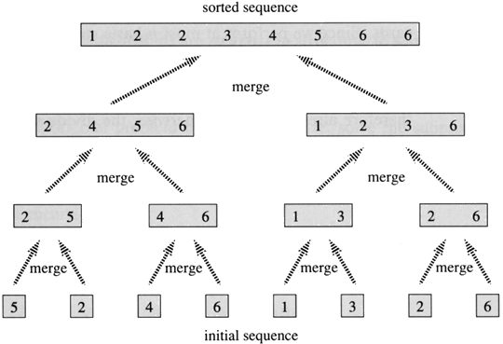

**Idea Behind Linear Time Merging**

Think of two piles of cards, Each pile is sorted and placed face-up on a table with the smallest cards on top. We will merge these into a single sorted pile, face-down on the table.

A basic step:

* Choose the smaller of the two top cards.
* Remove it from its pile, thereby exposing a new top card.
* Place the chosen card face-down onto the output pile.
* Repeatedly perform basic steps until one input pile is empty.
* Once one input pile empties, just take the remaining input pile and place it face-down onto the output pile.

**Running Time**

Each basic step should take constant time, since we check just the two top cards. There are at most *n* basic steps, since each basic step removes one card from the input piles, and we started with *n* cards in the input piles. Therefore, this procedure should take Θ(*n*) time.

int numbers[]={1,5,8,3,6,9,11};

int helper[7];

int number=7;

???what if we change (low < high) to (low <=high)

void mergesort(int low, int high) {

if (low <high) {

int middle = (high - low) / 2; // Get the index of middle element

mergesort(low, middle); // Sort the left side of the array

mergesort(middle + 1, high); // Sort the right side of the array

merge(low, middle, high); // Combine them both

}

}

void merge(int low, int middle, int high) {

int i = low;

int j = middle + 1;

int k = low;

// Copy both parts into the helper array. The key is this part which allows for the

//last item to be resolved in the right array.

for (int i = low; i <= high; i++)

helper[i] = numbers[i];

// Copy the smallest values from either left or right side back to the original array

while (i <= middle && j <= high) {

if (helper[i] <= helper[j]) {

numbers[k] = helper[i];

i++;

} else {

numbers[k] = helper[j];

j++;

}

k++;

}

// Copy the rest of the left side of the array into the target array

while (i <= middle) {

numbers[k] = helper[i];

k++;

i++;

}

/\***Don’t need to copy the right side into the target array because the last elements**

**will already be in the right place.** */

}

int main() {

mergesort(0, number - 1);

}

1,5,8,3,6,9,11

Numbers array

|  |  |  |  |  |  |  |  |  |  |  |
| --- | --- | --- | --- | --- | --- | --- | --- | --- | --- | --- |
| 0 | 1 | 2 | | 3 | 4 | | 5 | 6 | | Array subscript |
| 1 | 5 | 8 | | 3 | 6 | | 9 | 11 | |  |
| 1 | 5 |  | | | | | | | | Merge(0,0,1) |
|  | | 3 | | 8 |  | | | | | Merge(2,2,3) |
| 1 | 3 | 5 | | 8 |  | | | | | Merge(0,1,3) |
|  | | | | | 6 | | 9 |  | | Merge(4,4,5) |
|  | | | | | 6 | | 9 | 11 | | Merge(4,5,6) |
| 1 | 3 | 5 | | 6 | 8 | | 9 | 11 | | Merge(0,3,6) |
| **Mergesort (0, 6)**  Middle=3  Mergesort(0,3)  Mergesort(4,6)  Merge(0,3,6) | | | **Mergesort(0,3)**  Middle =1  Mergesort(0,1)  Mergesort(2,3)  Merge(0,1,3) | | | **Mergesort(0,1)**  Middle=0  Mergesort (0,0)  Mergesort(1,1)  Merge(0,0,1) | | | **Mergesort(0,0)**  DONE | |
| **MergeSort(1,1)**  DONE | |
| **Merge(0,0,1)**  1,5 | |
| **Mergesort(2,3)**  Middle=2  Mergesort(2,2)  Mergesort(3,3)  Merge(2,2,3) | | | **Mergesort(2,2)**  DONE | |
| **Mergesort(3,3)**  DONE | |
| **Merge(2,2,3)**  3,8 | |
| **Merge(0,1,3)**  1,3,5,8 | | | | |
| **Mergesort(4,6)**  Middle =5  Mergesort(4,5)  Mergesort(6,6)  Merge(4,5,6) | | | **Mergesort(4,5)**  Middle =4  Mergesort(4,4)  Mergesort(5,5)  Merge(4,4,5) | | | **MergeSort(4,4)**  DONE | |
| **MergeSort(5,5)**  DONE | |
| **Merge(4,4,5)**  6,9 | |
| **MergeSort(6,6)**  DONE | | | | |
| **Merge(4,5,6)**  6,9,11 | | | | |
|  | | | **Merge(0,3,6)**  1,3,4,6,8,9,11 | | | | | | | |